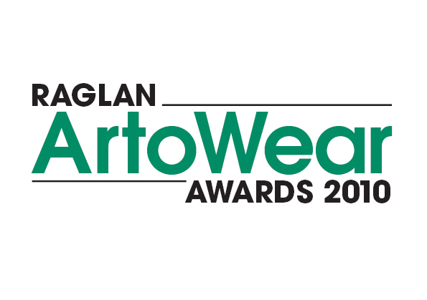
To whom it may concern, 20 February 2010

Please find attached entry forms and information about the
up and coming Raglan ArtoWear Awards to be held this
year over Queen’s Birthday week-end 5th June 2010 in the
Raglan Town Hall.
As you can see by the great section titles there is something
for everyone and wonderful prize money for the top three
place getters from Raglan Real Estate, Ray White & XTREME
WASTE will mean your hard efforts are well rewarded.
Please get in behind the competition and inspire your
students/ self to make this wearable arts parade the best
we have ever had.
Entry forms must be posted no later than Friday 28th May.

If you have any queries please contact:
Jean 07 8258877, Penny 07 825 0059,
info@raglanartscentre.co.nz
GOOD LUCK!

