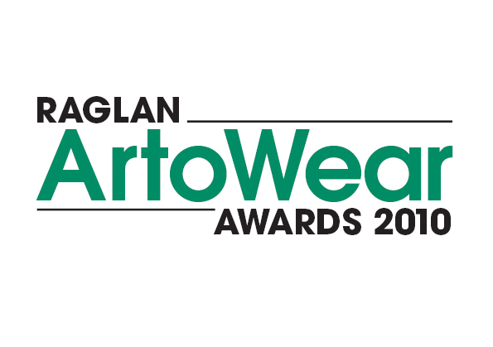
Saturday 5th June 2010

Presented by:
Raglan Community Arts Council

Raglan Town Hall
Bow Street, Raglan

Entries are invited for the
following sections:
‘Washed up’
‘GREEN’
Kiwiana Kitsch
Be Pacific
Crazy Creatures
Exhibition

2pm Afternoon Show
7pm Evening Show and Presentation of Awards

  Raglan Real Estate Ltd Licensed REAA (2008) 10th year celebration

Entry Information

There is no limit to the number of entires by any one artist

Entry forms and fees to be received by Friday 28 May:
Raglan ArtoWear Awards, P.O. Box 47, Raglan

$15 for one entry, $10 per entry thereafter
(includes 1 entry ticket to the evening show)

Each entry must have:
- The artwork’s name & artist’s name on each separate item of the outfit, including accessories.
- A photograph or drawing with a brief description of the artwork and number of pieces included. (Be creative & concise, this may be used in the garments commentary.)
- Garments must be strong enough to withstand rehearsals and show.

Registration Information

All artwork must be received at the Town Hall on Friday
4th June between 3pm & 6pm.
Dress rehearsal will be 10am Saturday 5th June 2010.
Afternoon and evening show tickets available from
Raglan Information Centre, Wallis St, Raglan.

Raglan Community Arts Council is not responsible for
cost of returning artwork.

This entry form constitutes permission for the entered
artwork to be filmed or photographed and it’s image
used be Raglan ArtoWear at some later date.

Prizes are awarded to all section finalists, from which
the Supreme Award winner will be chosen.
1st prize $1000
2nd prize $500
3rd prize $300

For more information contact:
Penny (07) 825 0059 or Jean (07) 825 8877
raglanevents@extra.co.nz

Entry form

Please use a separate form for each entry

Name:_______________________________________
Address:_____________________________________
____________________________________________
Email:_______________________________________
Phone:______________________________________
Title of Artwork:_______________________________

SECTIONS: (Please Circle)
- ‘GREEN’: Open
- Kiwiana Kitsch: Open
- Be Pacific: Pacifica - Open
- Crazy Creatures: Children’s section –under 13yrs
- Exhibition: Pre-shown garments
- ‘Washed up’ : sponsored by XTREME WASTE
(Recycled at least 80%) - Open

I am entering as: (Please Circle)
- Individual
- Student: Junior / Secondary/ Tertiary
- Whanau Collaboration (Involves more than one person in the making of the entry e.g. Parent and child, group of friends or colleagues.)

Model required: (Please circle)
Yes/ No Male/ Female

Fees:
CD of collective entry photos $10
DVD of Awards Show $20
Entry fee $15
Total enclosed____________________________

Post Entry Form and fee to:
Raglan ArtoWear Awards 2010
P.O. Box 47 Raglan
info@raglanartscentre.co.nz

Closing date for entries Friday 28 May 2010

